Project Report Template
Title of Project:MediTrack
Name of the Innovators:P. Chandu, P. Yaswanth, N. Jaswanth, P. Muni Babu, P. Mukesh
Individual/Team: Team
Team Size: 5
Start Date:14th Oct-2025
End Date:

Day 1: Empathise & Define
Step 1: Understanding the Need
- Which problem am I trying to solve?
Nowadays, due to heavy workloads, unhealthy eating habits, lack of regular exercise, and irregular diet routines, many people are facing unexpected health issues such as high blood pressure, diabetes, stress, anger, and even heart attacks.

- Who is affected by this problem?
These health issues mainly affect:
- Working professionals with busy schedules and high stress.
- Students who follow irregular sleep and eating habits.
- Business people who face constant pressure and long working hours.
- Middle-aged adults with sedentary lifestyles.
- Elderly individuals with poor diet control or lack of physical activity.

- How did I find out about this? [Select whichever is applicable]
  - Observing on online
  - Family Inputs
  - Used AI Tools
  - Review/Survey
Step 2: What is the problem?
In today’s fast-paced life, stress and long work hours have become common.
Unhealthy eating and lack of exercise worsen physical well-being, leading to lifestyle diseases like BP, diabetes, and heart problems.
My major focus is to create an easy-to-use health tracking application that even uneducated or layman users can use effortlessly.
_________________________________________________________________________________

Take-home task
Ask 2–3 people (you can speak to your family members, friends, teachers, trainers) what they think about this problem. Write down surprising or new things you learn below.
Working Professional:20 Members
Honestly, I feel this every day. My job keeps me glued to my laptop for hours. By the time I finish work, I’m too tired to cook or exercise. An easy health tracker app would really help me stay aware of my habits.

Auto Driver, Construction Workers, Daily Wage Workers etc…: 15 Members
We don’t have time to think about health. We eat whenever possible, mostly hotel food. If your app is simple and works in local languages, it’ll help people like me check BP or sugar on time.
College Student’s: 50 Members
Students also face stress and irregular eating because of classes and deadlines. I think this kind of app can remind us to drink water, take breaks, and maintain balance.
Retired Person: 10 Members
In our age, health problems come quickly. Many of my friends can’t use complex apps. If your app is simple and voice-based, even elders can manage their health better.

AI Tools you can use for Step 1 and 2:
- ChatGPT: Use it to brainstorm different ways the problem might affect people.Gather facts, stats, or examples related to the problem.
Day 2: Ideate
Step 3: Brainstorming solutions [Prompt: “I am ideating solutions for <enter your problem in detail> Suggest 5 unique solutions for this problem, which I can easily accomplish in 2 days using free, open-source mobile-friendly AI tools”]
- List at least 5 different solutions (wild or realistic):
      - Simple Health Tracking App
      - Daily Wellness Routine Programs
      - Smart Diet Suggestions
      - Community Awareness Campaigns
      - Health Monitoring Devices Integration
Step 4: My favourite solution:
- Simple Health Tracking App (with voice and local language support)

Step 5: Why am I choosing this solution?
- It’s practical, inclusive, and scalable, making it the strongest solution to build real health awareness in daily life.
Take-home task
Generate the image of your solution and how it will look (eg: “a bag that charges your phone while you walk”)
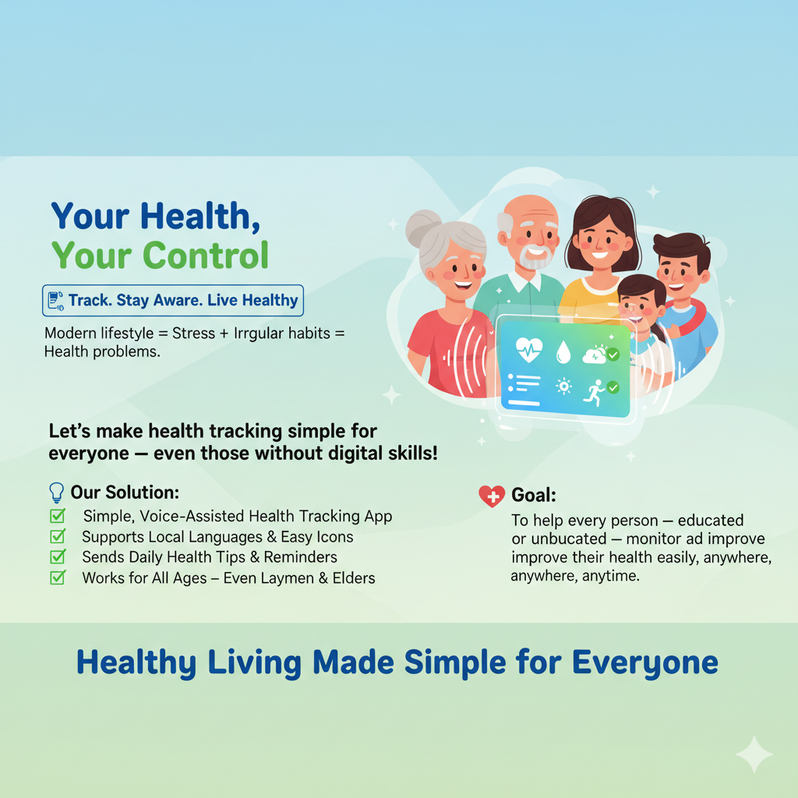

AI Tools you can use for Step 3-5:
- ChatGPT for image prompt
- Gemini for Image Creation
Day 3: Prototype & Test
Step 6: Prototype – Building my first version
- What will my solution look like?
My solution looks as shown below
________________________________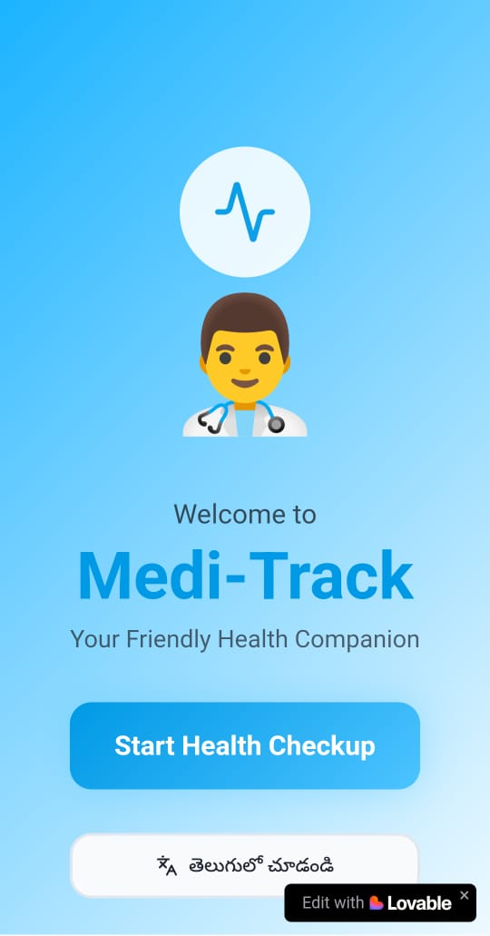_________________________________________________
- What AI tools will I need to build this?
Chatgpt palys akey role in building this software
- Text-to-Speech (to speak instructions)
- Google Text-to-Speech
- Amazon Polly
- Speech-to-Text (to understand user voice input)
- Google Speech-to-Text
- OpenAI Whisper
- Image Support
- Use simple icons and illustrations
- (Optional) Use Google ML Kit if you want to scan objects or medicines
- Language Translation
- Google Translate API (for multiple languages)
- Health Data Analysis (for BP, sugar, etc.)
- Use TensorFlow Lite
- Chat Support (Optional)
- Dialogflow or ChatGPT API
_________________________________________________________________________________
- What AI tools I finally selected to build this solution? [Eg: Claude AI, Grok AI, Chatling AI]
- ChatGPT API
- _Gemini_
- _meta_
<BUILD YOUR INNOVATION><TEST YOUR INNOVATION>
Step 7: Test – Getting Feedback
- Who did I share my solution with? [You may share it with your trainer, peers or even AI]
I shared my Medi-Track solution with my trainer and peers to get feedback on the usability and effectiveness of the app. I also used AI tools like ChatGPT to refine the idea, choose suitable technologies, and make the app more user-friendly for uneducated users.
________________________________________________________________________________
- What feedback did I receive?
The best feedback I received was that the app is very easy to use and understandable, especially for people who cannot read. The use of clear images and voice instructions was appreciated, and it was mentioned that the app could really help people in rural areas manage their health more independently.
👍 What works well:
The best feedback I received was that the app is very easy to use and understandable, especially for people who cannot read. The use of clear images and voice instructions was appreciated, and it was mentioned that the app could really help people in rural areas manage their health more independently.

🔧 What needs improvement:
Some users suggested adding more local language voice support for better understanding. Also, improving the image clarity and making the app work offline would help users in areas with poor internet connectivity. The app could also benefit from a simpler way to enter health data, like voice input or automated readings.
Take-home task
Record your solution and test feedback in voice notes. Upload your voice notes, images and your solution/model on GitHub
AI Tools you can use for Step 6-7:
ChatGPT/Perplexity AI/Claude AI/Canva AI/Chatling AI/Figma AI: You can use these tools to build solutions/models or mock-up dummy prototypes

Day 4: Showcase
Step 8: Presenting my Innovation
- Final Project Title:Medi-track
_________________________________________________________________________________
- Document key points of my presentation:
[Prompt with attachment/screenshot of your solution: “I am ideating a solution for <enter your problem in detail> I have selected a solution which includes <enter your solution description> I tested the solution with <enter details of who tested your solution> and they gave the following feedback <enter feedback given by the testers> Generate a 1-minute pitch document with following headings: project title, problem statement, my innovation, feedback I received from users, impact of my innovation. Add the attached image in the pitch document”]
- A medical-based app designed for uneducated and rural people.
- Simple voice-guided interface with local language support.
- Helps users track health, get medicine reminders, and access emergency help easily.
- Uses AI voice assistance and easy icons instead of text.
- Aims to make healthcare accessible for everyone, regardless of education level.
- Future features: wearable device connection and doctor chat support.
<SHOWCASE YOUR INNOVATION TO YOUR PEERS>
Step 9: Reflections
What did I enjoy the most during this project-based learning activity?
- enjoyed creating a simple, voice-guided medical app that helps uneducated people manage their health easily.
It was rewarding to see how technology can make healthcare more accessible for everyone.
What was my biggest challenge during this project-based learning activity?
- My biggest challenge was designing the app interface simple enough for uneducated users to understand.
It was also difficult to add voice and language features that work smoothly for everyone.
________________________________________________________________________________

Take-home task
Upload your pitch document on GitHub
AI Tools you can use for Step 8:
Canva AI: You can use this to design your pitch document. Download your pitch document as a PDF file and upload on GitHub

